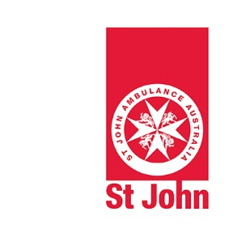

Safety

Covering:
HLTWHS002 Follow safe work practices for direct client care
HLTINF001 Comply with infection prevention and control policies and procedures

Event Health Services

Workbook

Insert your name in the box provided and complete the declaration.
Participant Name:
Declaration: | ☐ I confirm that this is my own work.
Signature:
Date:

This Workbook must be submitted within 30 days after completing the workshop.

© St John Ambulance Australia 2020

This publication is copyright. Apart from fair dealings for purposes of private study, criticism or review, as permitted under the Copyright Act, no part may be reproduced by any process without written permission.

All enquiries about this document and any proposed amendments for its improvement should be directed to:

National Training and Innovation Manager
St John Ambulance Australia
PO Box 292
Deakin West ACT 2600
Email: training@stjohn.org.au

Contents
Introduction 3
A. Workplace Health and Safety 4
B. Infection Prevention and Control 11
Assessment Outcome 19

Introduction
You are required to complete some short answer questions about workplace health and safety and infection prevention and control.
Further instructions are provided for each of these activities below. The boxes in grey are to be completed by your assessor.
Refer to the Reference Materials to assist you in completing answers to some of the questions. You will need to use the Internet or other reference sources to complete some of the questions.
In addition, you will need to complete the following practical skills during the workshop for this course:
- Infection prevention and control procedures
- Infection risk management
- Incident report
- Manual Handling
- Emergency procedure
- Workplace health and safety meeting

Workplace Health and Safety
Instructions: Write your answers in the spaces provided. You must correctly answer every question.

- What is the name and year of the Workplace Health and Safety Act in your State/Territory?

Name of Act
Year

- What is the name and date of the Code of Practice covering first aid in the workplace in your State/Territory?

Name of Code
Year (most recent release)

- What is the name of your State/Territory Workplace Health and Safety Authority?

- What are three (3) of your rights as an employee under the Work Health and Safety Act?

- What are three (3) of your responsibilities as an employee under the Work Health and Safety Act?

- What are three (3) of your employer’s rights under the Work Health and Safety Act?

- What are three (3) of your employer’s responsibilities under the Work Health and Safety Act?

- Complete the table with information related to “duty of care”

- What is duty of care?
- How does “duty of care” apply to employers in relation to Workplace Health and Safety?
- How does “duty of care” apply to employees in relation to Workplace Health and Safety?

- What is the name and date of the code of practice covering managing hazardous manual tasks in your State/Territory?

Name of Code
Year (most recent release)

- What is the name and date of the health industry standards that cover infection prevention and control in the health industry?
Name of Standard
Year (most recent release)

- Identify at least one (1) situation where you would use each of the signs below.

Safety sign/symbol | Situation for use | Safety sign/symbol | Situation for use
- 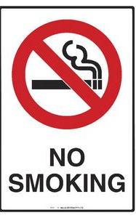 |  | 6.
- 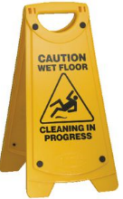 |  | 7. 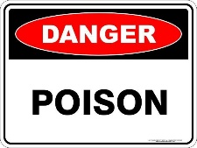
- 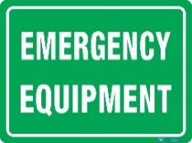 |  | 8. 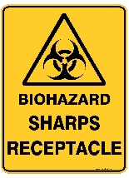
- 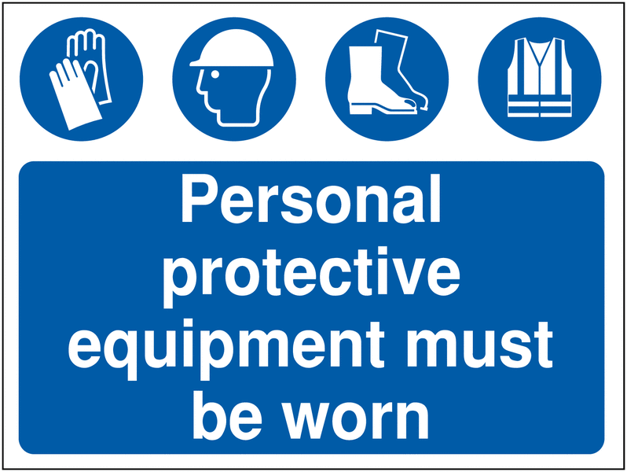 |  | 9. 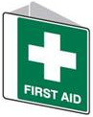
- 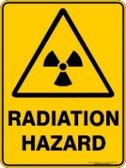 |  | 10.

- What is the definition of a hazard?

- Name two (2) hazards relevant to your work in St John under each of the following categories:

Category | Hazards
Manual tasks | 1.  2.
Infection control | 1.  2.
Personal safety | 1.  2.

- At what step in the DRSABCD procedure, do you identify hazards?

- Rank the following ways of controlling a hazard (in order from 1 to 6):

Control measure | Rank
Reduce exposure to the hazard using administrative action (such as developing policies and procedures)
Isolate the hazard from people
Use personal protective equipment
Substitute the hazard with something safer
Eliminate the hazard
Reduce the risk through engineering controls such as machine guards

Safety when working in a home environment
- What are three (3) of your client’s rights under the St John Patient charter?

- What are three (3) of your client’s responsibilities under the St John Patient charter?

- One possible danger when entering a home is being caught by a fire. Complete the following table related to house fires.

- Name one (1) high risk group that is most likely to be impacted by a fire in a house.
- Name one (1) client behaviour that is most likely to cause a fire in a house.
- What would you check about a smoke alarm in a house? (select all that apply) | - Installed  - Colour matches the ceiling colour  - Checked regularly  - Batteries are working  - Made by an Australian manufacturer  - Placed near the bedroom

- List four (4) risk factors that need to be considered when working with a patient in a home-base environment? (e.g. messy environment meaning that it would be difficult to get a stretcher to a patient).

- Define each of the following components of the musculoskeletal system.

Parts of the Musculosketal system | Definition
Bones
Muscles
Tendons
Ligaments
Joints

- List four (4) practices you should follow to minimise injury to yourself and clients when moving patients.

- List the four (4) major steps in emergency evacuation procedures.

- Name two (2) St John Workplace Health and Safety procedures that must be followed.

Short Answer Questions

Q Number | S | NYS | Q Number | S | NYS | Q Number | S | NYS
Question 1 |  |  | Question 9 |  |  | Question 17
Question 2 |  |  | Question 10 |  |  | Question 18
Question 3 |  |  | Question 11 |  |  | Question 19
Question 4 |  |  | Question 12 |  |  | Question 20
Question 5 |  |  | Question 13 |  |  | Question 21
Question 6 |  |  | Question 14 |  |  | Question 22
Question 7 |  |  | Question 15 |  |  | Question 23
Question 8 |  |  | Question 16
Feedback if not yet satisfactory

Infection Prevention and Control

Guidelines for the prevention and control of infection.
St John follows the Australian Guidelines for the Prevention and Control of Infection in Healthcare developed by the National Health and Medical Research Council (NHMRC) and the Australian Commission on Safety and Quality in Health Care. The latest version was published in May 2019.The first 15 questions relate to these guidelines.

- In accordance with NHMRC guidelines, name three (3) situations when routine personal and hand hygiene should be performed.

- What are the six (6) steps on hand washing using soap and water according to the NHMRC guidelines?

1
2
3
4
5
6

- What are the three (3) steps on use of alcohol-based hand rub according to the NHMRC guidelines?

1
2
3

- Circle Yes or No in the table below to indicate which practices are recommended in the NHMRC guidelines for pre-surgical hand preparation.

Practice
- Remove hand jewellery | Yes No
- Remove nail polish | Yes No
- Soak fingers in disinfectant for 5 minutes | Yes No
- Remove debris from underneath fingernails | Yes No
- Use a surgical alcohol-based hand rub | Yes No

- According to the NHMRC guidelines, indicate if the following statements are True or False. Circle your answer.

Statement
- Alcohol-based hand rub is the preferred hand hygiene practices in health care settings. | True False
- Hand washing is preferred for situations when the hands are visibly soiled. | True False

- Use the information provided in NHMRC guidelines to indicate if the following statements are True or False. Circle your answer.

Statement
- Cuts and abrasions should be covered with waterproof dressings. | True False
- It is okay to wear artificial fingernails when working in health care. | True False
- The wearing of rings when working in health care is strongly discouraged. | True False

- According to NHMRC guidelines, name two (2) situations when gloves should be used?

- According to NHMRC guidelines, why should you wear gowns and waterproof aprons?

- According to NHMRC guidelines, when should you wear masks?

- According to NHMRC guidelines, why should you wear safety glasses?

- According to NHMRC cleaning guidelines, indicate if the statements below are True or False. Circle your answer.

Statement
- The frequency of cleaning is determined by risk analysis and reflected in health care facility policy. | True False
- All surfaces must be cleaned with disinfectant. | True False
- Cleaning with detergent and water is the most useful method for removing germs from surfaces. | True False

- According to the NHMRC cleaning guidelines, what are two good practice statements for routinely cleaning surfaces:

1
2

- Place the steps in the table in the correct order (from 1-8) to meet NHMRC’s guideline on cleaning a large blood spill.

Perform hand hygiene
Discard contaminated materials
Mop the area with detergent solution
Use scraper to scoop up absorbent material
Select appropriate PPE
Wipe the area with sodium hypochlorite and allow to dry
Cover area of spill with clumping agent
Place contaminated items into plastic bag

- Use NHMRC guidelines on handling single-use sharps to answer the following questions.

- What should you do with a single-use sharp immediately after use?
- Who is responsible for this action?

- According to NHMRC guidelines on reprocessing of equipment and instruments, what four (4) procedures must be followed?

- For each of the additional (or transmission-based) precautions listed below, identify the type of precautions (contact, droplet or airborne) for which they should be used and give a specific example of when they would be used.

Precaution | Type of precaution | Example of use
- Surgical mask
- P2 (N95) respirator

- Name two (2) potential infection hazards relevant to your work in St John. For each hazard outline one (1) associated risk and one (1) control measure that could be implemented.

 | Hazard | Associated risks | Control measures
1
2

- What is the ‘çhain of infection’?

- In relation to the ‘Chain of infection’, name three (3) infectious agents.

- In relation to the ‘chain of infection’, name three (3) modes of transmission for an infectious agent.

- Define the term ‘susceptible host’.

- Give the definition of each of the following terms:

Bacteria
Bacteria spores
Fungi
Viruses
Pathogens
Harmless micro-organism
Infection
Disease
Colonisation

- For each of the following modes of transmission, give an example of how you would break the chain of infection?

Contact
Airborne
Droplet
Penetrating Injury

- Name any two (2) strategies that have been implemented in Australia since the start of the COVID -19 pandemic, to limit the spread and reduce the risk of infection to the public.

- Select Yes or No for each of the statements in the table to indicate the most likely potential sources of influenza

Potential Source
A person who has the signs and symptoms of influenza (coughing, runny nose, sore throat) | Yes No
A person who has influenza but has not yet shown the signs and symptoms | Yes No
A person who has been vaccinated against influenza | Yes No

- Describe how each of the factors below increases susceptibility to infections.

Factors | Susceptibility to infection
- Immune status
- Wounds
- Medical Devices
- Medications
- Comorbidities
- Age

Short Answer Questions

Q Number | S | NYS | Q Number | S | NYS | Q Number | S | NYS
Question 1 |  |  | Question 10 |  |  | Question 19
Question 2 |  |  | Question 11 |  |  | Question 20
Question 3 |  |  | Question 12 |  |  | Question 21
Question 4 |  |  | Question 13 |  |  | Question 22
Question 5 |  |  | Question 14 |  |  | Question 23
Question 6 |  |  | Question 15 |  |  | Question 24
Question 7 |  |  | Question 16 |  |  | Question 25
Question 8 |  |  | Question 17 |  |  | Question 26
Question 9 |  |  | Question 18
Feedback if not yet satisfactory

Assessment Outcome

Participant Name:

 | Outcome |  | Re-Assessment
Assessor to Complete | S | NYS | S | NYS
- Workplace Health & Safety
- Infection Prevention and Control

Feedback:

 | Satisfactory | Not Yet Satisfactory
Overall Outcome of Assessment
Assessor Name:
Signature:
Date:

